MODULE 7 GROUP ASSIGNMENT

STAKEHOLDER MANAGEMENT PLAN

Project Name: University-Wide Print and Projection Upgrade

Project Duration: 60 Days

Prepared by: Gladis Munoz Marin, Heidi Schieber, Prabesh Rai, Sirona Ramahi, Angelina Gochenour

ITEC 380: Managing IT Projects
Professor: Jose (Joe) Ascensio

OCT 6 2025

Introduction
The Stakeholder Management Plan outlines strategies to identify, engage, communicate with, and manage all project stakeholders throughout the University-Wide Print and Projection Upgrade. The goal is to ensure stakeholder needs and concerns are understood and addressed while keeping the project aligned with its goals of completing all hardware replacements within 60 days, minimizing operational disruptions, and maximizing campus-wide cooperation.
The plan directly supports the project’s key success objectives related to the human resource management plan and communication plan to ensure consistency across the planning and project phases.
- Minimizing resistance and maximizing support for installation and training phases.
- Ensuring timely access to resources
- Aligning stakeholder expectations with the project’s scope and schedule.
Stakeholder Analysis and Prioritization
Stakeholders are categorized based on their level of influence and level of impact on the project. This will help the team to devise an appropriate engagement strategy to keep the stakeholders supportive and engaged.

Stakeholder Prioritization Summary
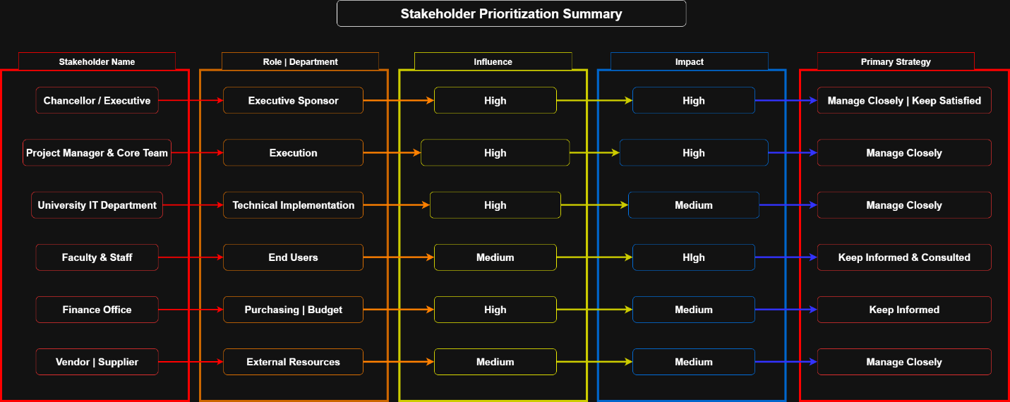

Engagement Strategy and Response Action
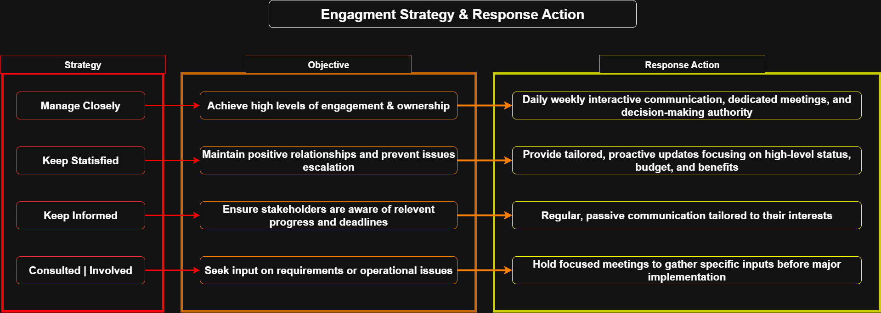

Engagement Assessment Matrix
The Stakeholder Engagement Assessment Matrix below provides a structured view of where key stakeholders currently stand, ranging from neutral to supportive or leading—and outlines targeted strategies to close any engagement gaps. This tool enables the project team to focus efforts where they are most needed, ensuring proactive communication, minimizing resistance, and aligning stakeholder involvement with project goals.
Stakeholder | Current Engagement | Desired Engagement | Strategy
Chancellor | Supportive | Leading | Provide executive summaries and critical issue alerts to maintain strategic alignment.
Faculty and staff | Neutral | Supportive | Deliver personalized training, FAQs, and create open channels for feedback.
Vendor/Supplier | Supportive | Supportive | Maintain weekly coordination calls and shared progress updates.
IT Department | Involved | Leading | Engage in daily sync meetings, shared documentation, and empower with decision-making authority where applicable.

Communication Integration
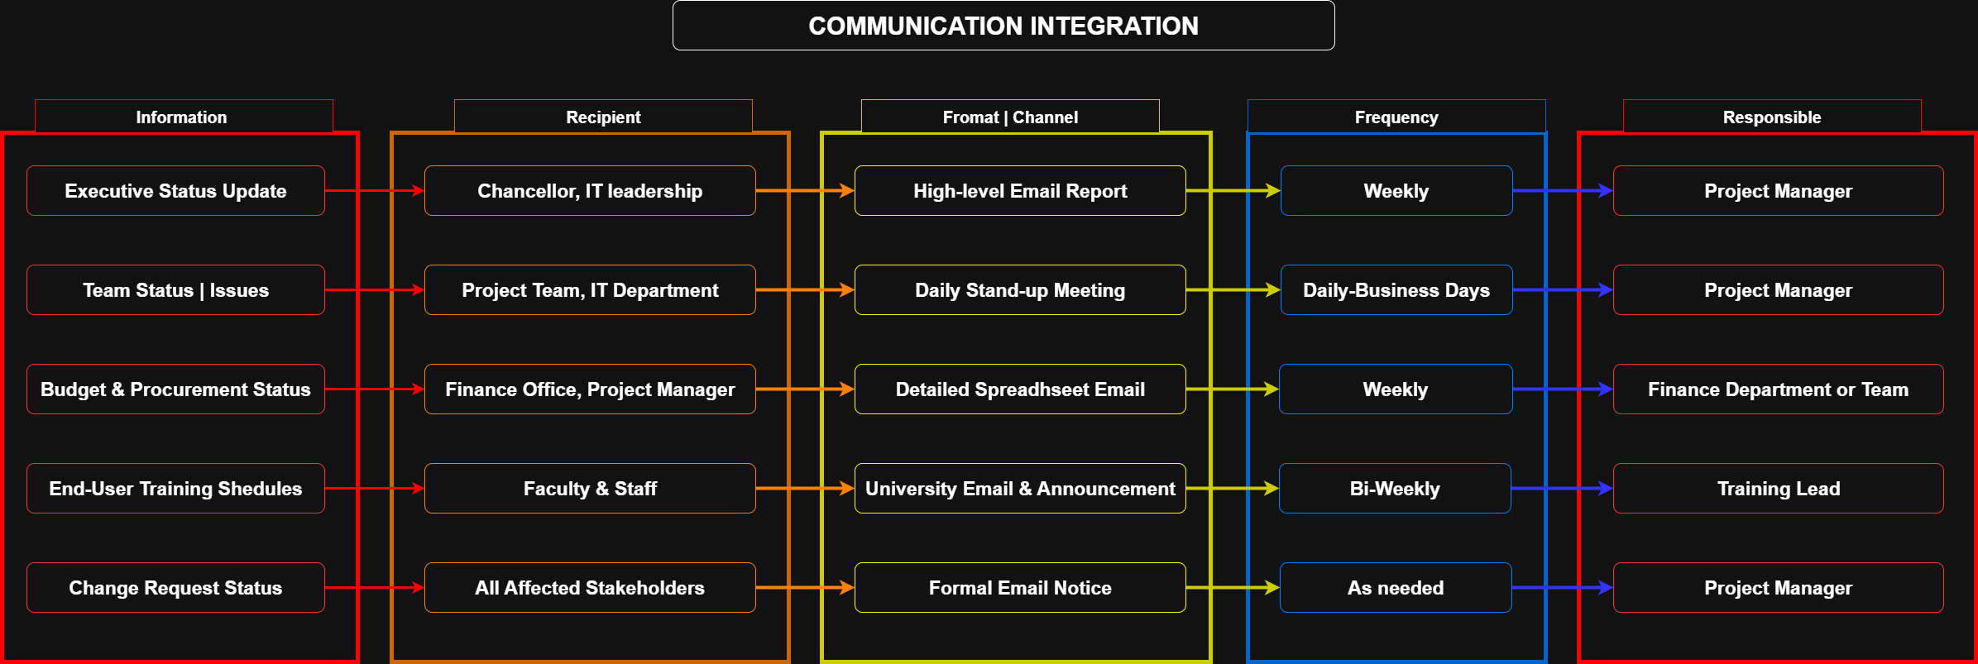

Key stakeholder Engagement Activities
The critical alignment meeting and post-installation engagement will ensure stakeholder involvement and alignment, particularly concerning operational disruptions.
Critical Alignment Meeting
The meeting focused on aligning objectives and expectations will be conducted early in the planning phase to ensure consensus on the vendor and minimize end-user disruption.
Detail | Description
Purpose | To finalize logistics, confirm availability, and establish the process for installation and training with departmental representatives.
Duration Format | 2.5 Hours (including a 15-minute break), conducted via Zoom for maximum attendance flexibility.
Proposed Attendees | Project Manager, Technical Lead, Training Lead, and key leaders & stakeholders
Proposed Agenda | - Classroom and office downtime windows for installation  - How departments will be notified (and by whom)  - Confirm access needs for weekends/off-hours.  - Backup print/scan solutions if any installation delays occur.  - Training needs per department

Post-Installation Engagement
After physical installation the engagement shifts to support and integration.
- Training sign-off: Department leaders will formally sign off the completion and quality of the training delivered during the transition phase.
- Support and implementation: Establish inclusive live support by the IT department team, who are trained on the new hardware and system.

Potential Risks & Mitigation (from Stakeholder Viewpoint)
Risk | Mitigation Strategy
Poor Communication | Create and follow a clear communication plan with tailored communication strategies for each individual stakeholder.
Resistance to Change | Emphasize the benefits of the new software, keep stakeholders informed regularly, and utilize demonstrations to showcase software and hardware.
Conflicting Stakeholder Interests | Facilitate meetings between stakeholders where they discuss their interests and come to a satisfactory compromise.
Incongruous Stakeholder Identification | Thoroughly identify and classify all possible stakeholders, ensuring none are overlooked or under-involved.

Conclusion
Effective stakeholder engagement is critical to the success of this time-sensitive, campus-wide upgrade. Through consistent communication, clearly defined roles, and proactive problem-solving, this plan ensures that all stakeholders are aligned and equipped to support the project goals.

Time Log:
